Making Mud Shakes To Learn About Soil
A lesson from the New Jersey Agricultural Society
Learning Through Gardening Program
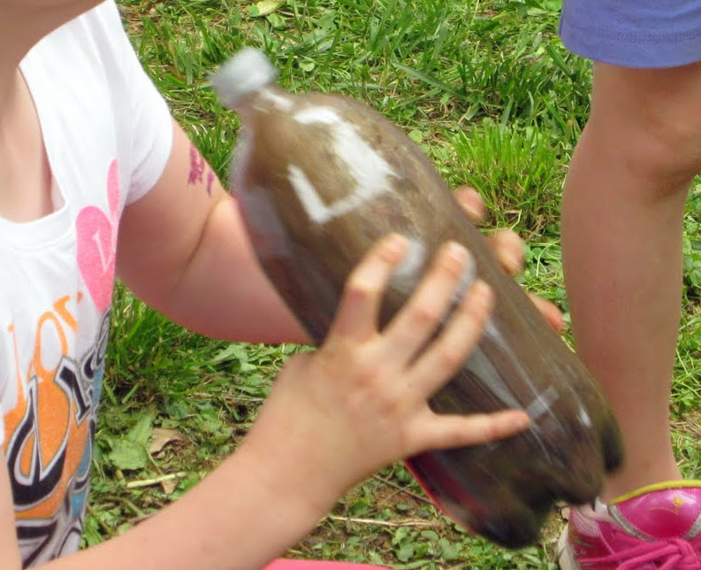
Objectives: The student will be able to:
- Name the three types of sol:l sand, silt, and clay
- Define silt as the best soil for plants because it can hold just enough water for plants and let in air.

Grades: 2-5

Materials:
a 2-liter plastic bottle with screw top for each group of students
For each bottle you will need:
one cup of sand (play sand is fine)
one cup of clay (available in most New Jersey backyards)
one cup of soil from the school garden
funnels made from the tops of 2-liter bottles (enough for each student group to have one). To make a funnel, cut the top off a 2-liter bottle and turn it over
water
a small watering can or empty gallon milk jug for each group to use to hold water
“Types of Soil Experiment” worksheet

Procedure:
Ask students if plants can grow in any type of soil. What type of soil is it difficult for plants to grow in? Explains the three types of soil – sand, silt, and clay.

Sand is the biggest and heaviest type of soil with more space in between particles so that water can run through it easily. Clay is the smallest and lightest type of soil that is packed together so tightly it is difficult for water to run through it. Silt is the “just right” medium-sized type of soil that allows water to move slowly through it so plants can catch the water with their roots.

The teacher can demonstrate how water runs through each type of soil by drawing circles on the board – big circles spaced far apart for sand, medium-sized circles spaced closer together for silt, and small circles spaced close together for clay.

The soil in our garden is made up of silt that is good for plants. Today we are going to make mudshakes to compare this silt to the other types of soil – sand and clay.

Divide the students into small groups of three to five. Ask the students to fill a two-liter soda bottle two-thirds full with water. Using a cut-off soda bottle top as a funnel, the students add one cup each of clay, sand, and garden silt to the bottle. (This process is easier if you use duct tape to secure the funnel to the bottle.) The sand and garden silt will be easy to put into the bottle. The students will have to use a pencil to push the clay through the funnel.

Next seal the bottle cap on tightly. Give each child in the group a chance to shake the bottle vigorously until the water and soil is mixed well. (It defuses arguments to ask each child to take a turn shaking by counting to 10 and then giving someone else a turn.) Ask the students to let the bottles stand in their classroom until the water at the top is fairly clear. This may take several days. Do not move the bottles.

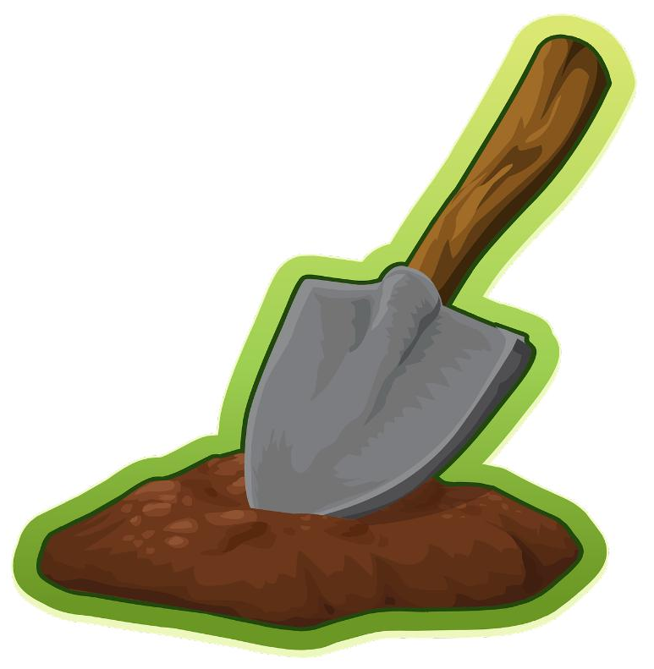
The students should see the three different type of soil settle in layers. The sand will be the heaviest and will be at the bottom. The silt will be in the middle. The clay will be the lightest and will be at the top. Look at the surface of the water. Is there some plant material floating there? How does your garden soil compare to the other soil?

Evaluation:
Students will be able to list the three types of soil. Students will be able to tell which type of soil is most desirable for plants and why.
Completed “Types of Soil Experiment” worksheet

Extension: Read and discuss Steve Tomecek's book Dirt.
NAME____________________________

Types of Soil Experiment

There are three types of soil. Sand is the largest and heaviest. Silt is medium-sized. Clay is the smallest and lightest.

Describe the contents (what's inside) of one of the soil bottles after it's just been shaken.

_____________________________________________________________

_____________________________________________________________

Describe the contents of one of the soil bottles the next morning.

_____________________________________________________________

_____________________________________________________________

Describe the contents of one of the soil bottles after three days. Do you see any layers?

_____________________________________________________________

_____________________________________________________________

_____________________________________________________________

Why do you think the soil settled the way it did?

_____________________________________________________________

